

CLOUD COMPUTING LAB
BSE ( V-B )

Submitted By:
Musfira Farooq
Roll No:
2023-BSE-045
Submitted To:
Sir Muhammad Shoaib

LAB 12

Terraform Provisioners, Modules & Nginx Reverse Proxy/Load Balancer

Task 0 – Codespace & GitHub CLI Setup
- Repository Creation and Codespace Listing
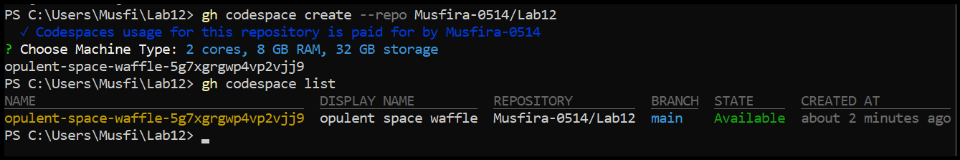
- Successful SSH Connection to Codespace
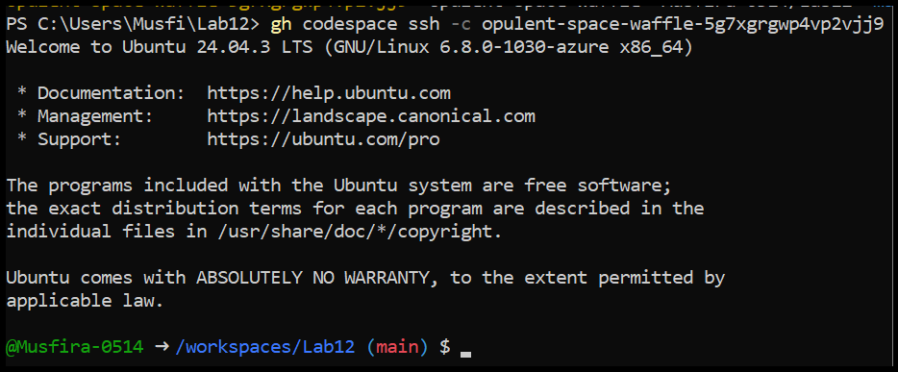
Task 1 – Terraform File Organization
- Project Directory Creation
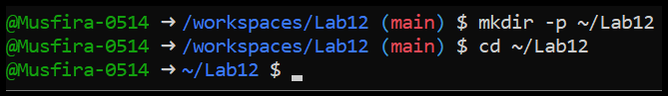
- Creation of Terraform Configuration Files
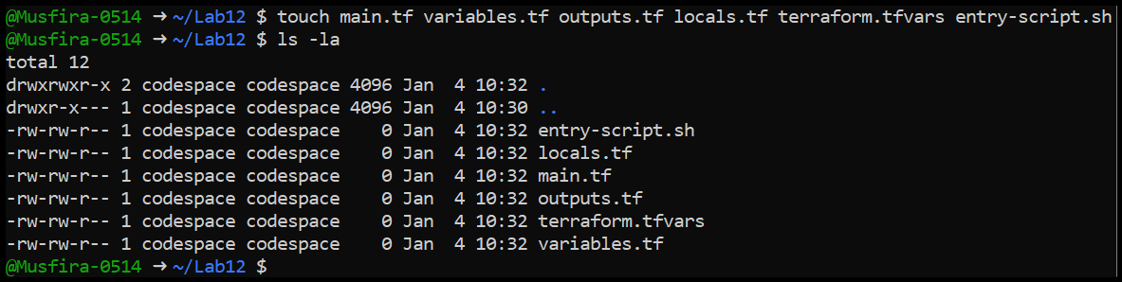
- Definition of Input Variables
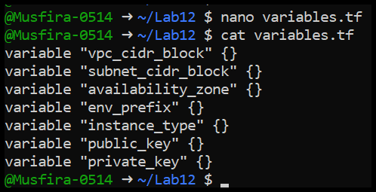
- Definition of Output Values
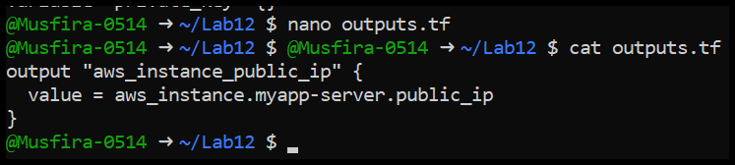
- Local Variables and Public IP Detection
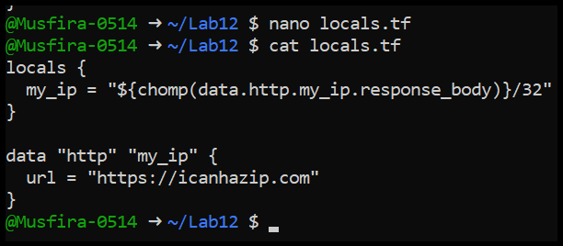
- Terraform Variable Values File
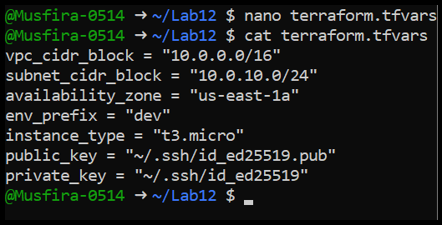
- Main Terraform Configuration
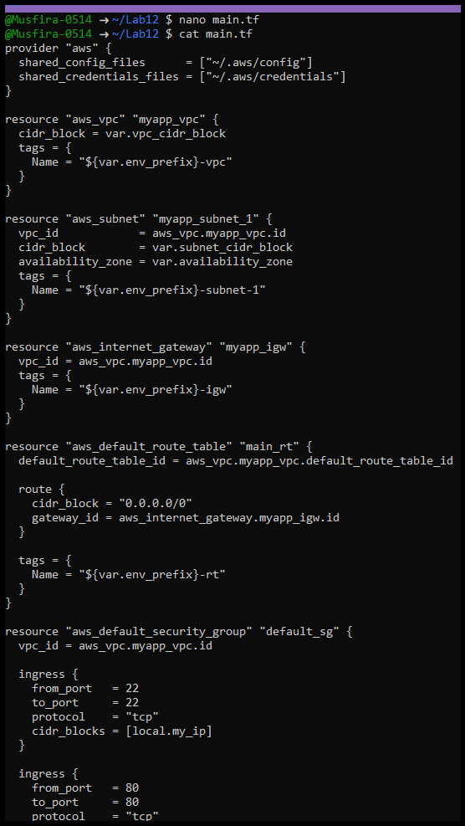
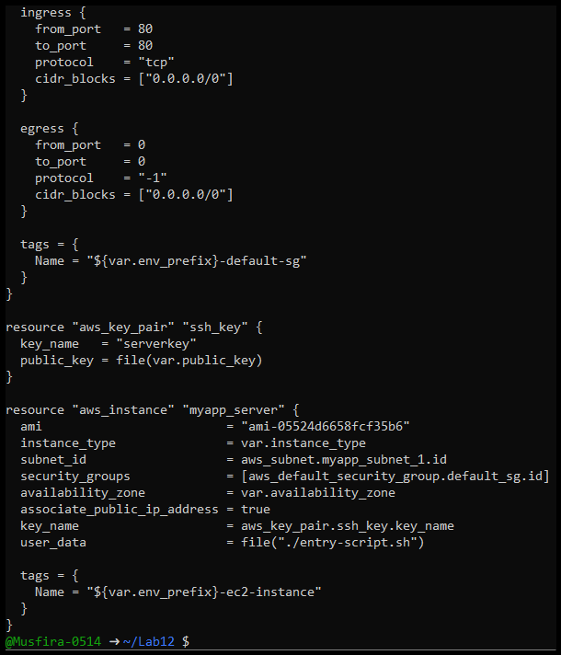
- User Data Script for Nginx Installation
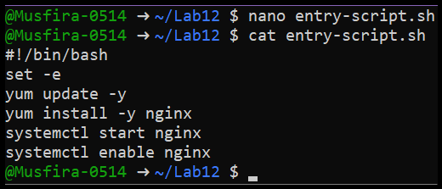
- SSH Key Pair Generation
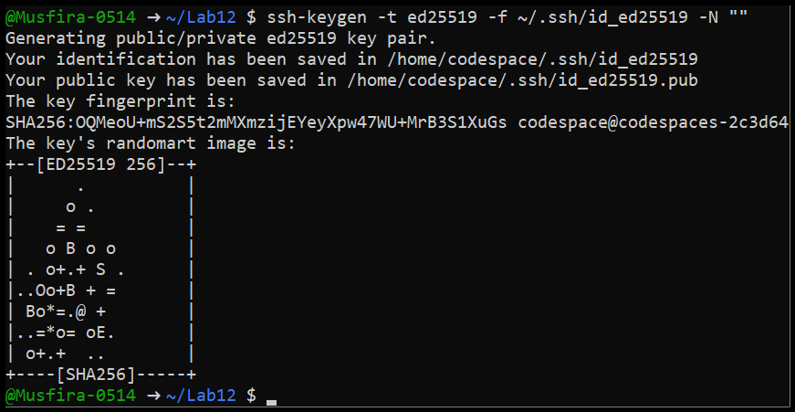
- Terraform Initialization
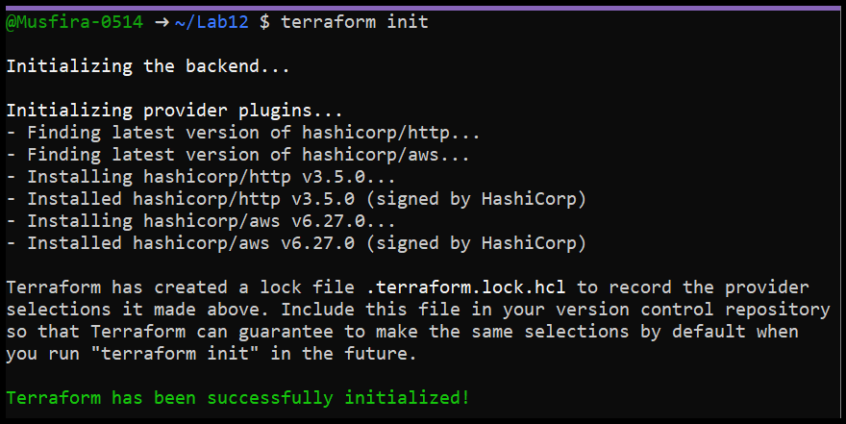
- Infrastructure Provisioning Using Terraform
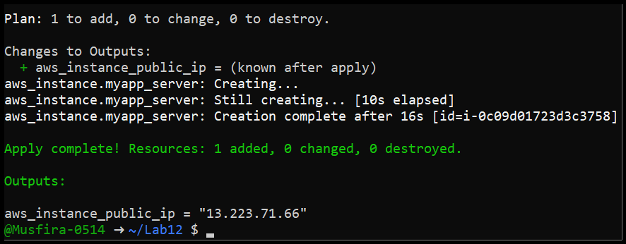
- Terraform Output Showing Public IP
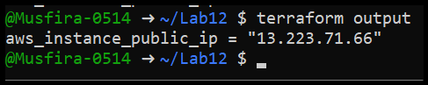
- Verification of Nginx Default Page
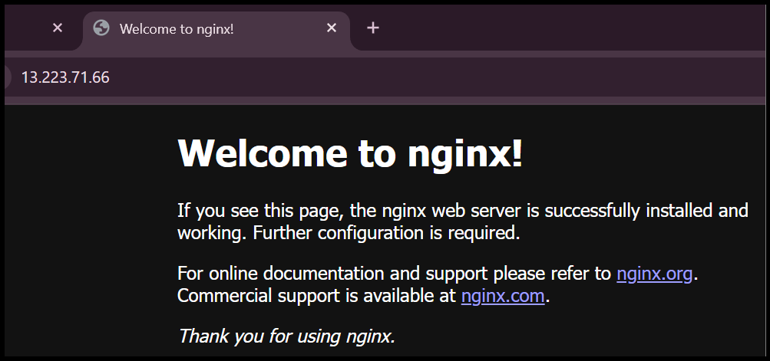
- Destruction of Terraform Resources
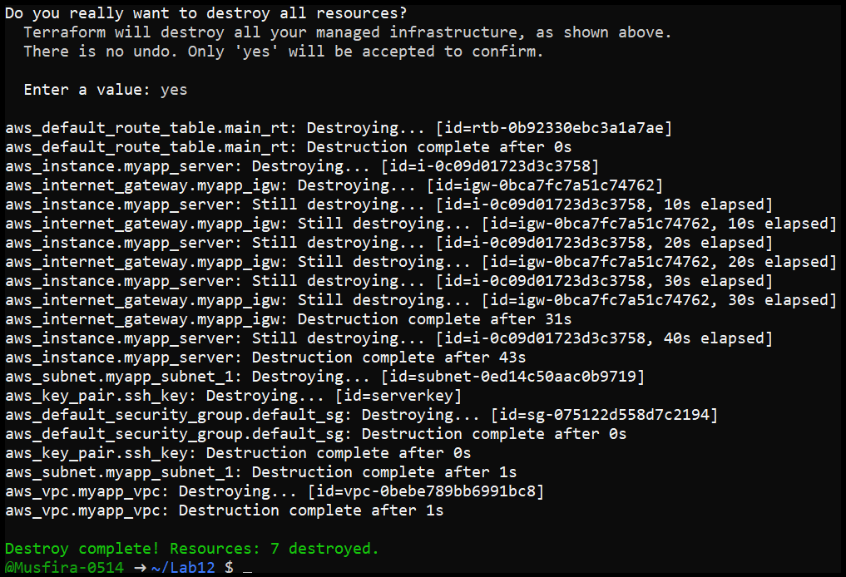
Task 2 – Remote-Exec Provisioner
- Configuration of Remote-Exec Provisioner
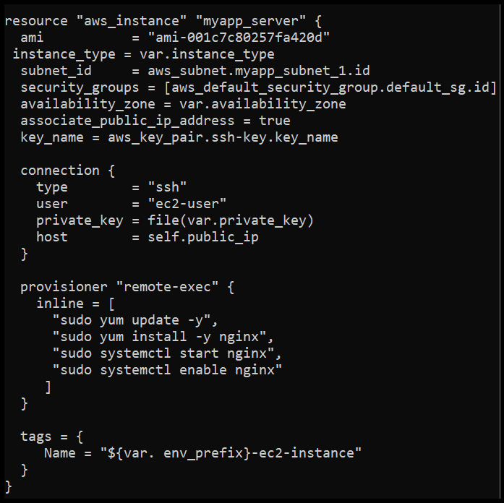
- Execution of Remote Commands via Terraform
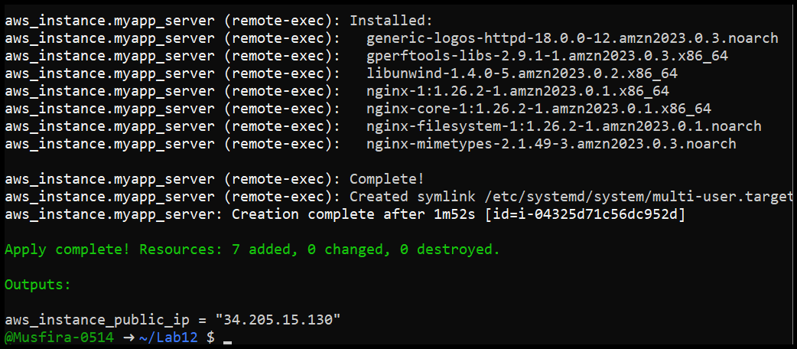
- Terraform Output After Remote Execution
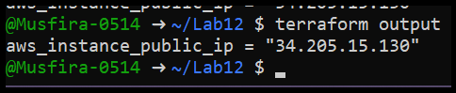
- Browser Verification of Nginx Service
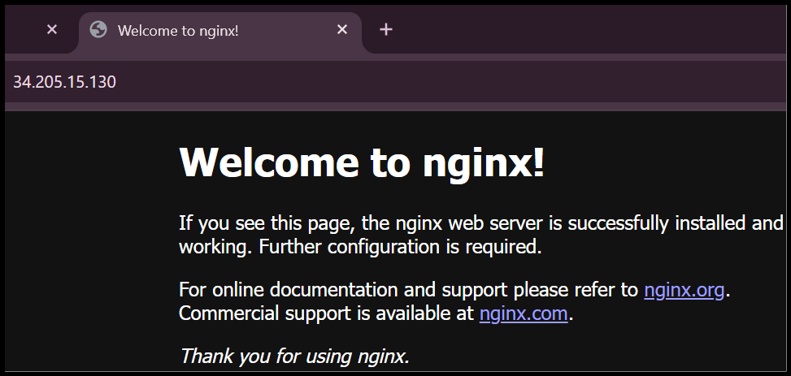
Task 3 – File and Local-Exec Provisioners
- Configuration of File, Remote-Exec and Local-Exec Provisioners
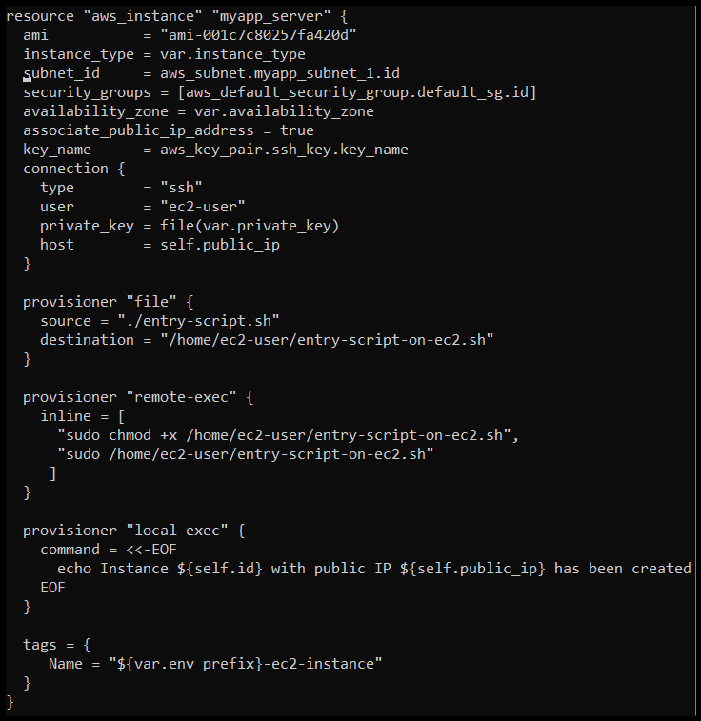
- Successful Execution of All Provisioners
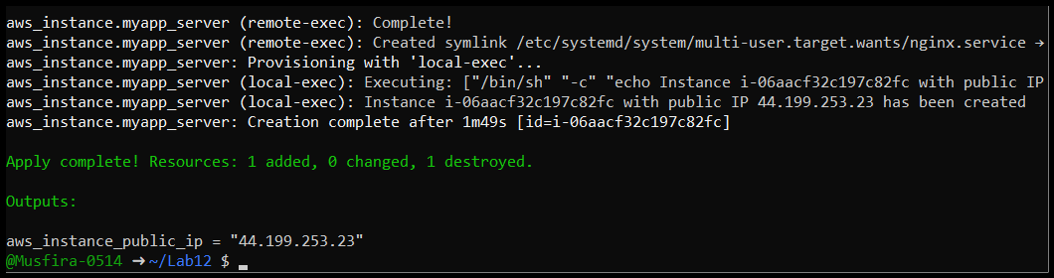
- Terraform Output Displaying Instance IP
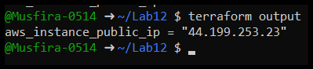
- Verification of Nginx Deployment
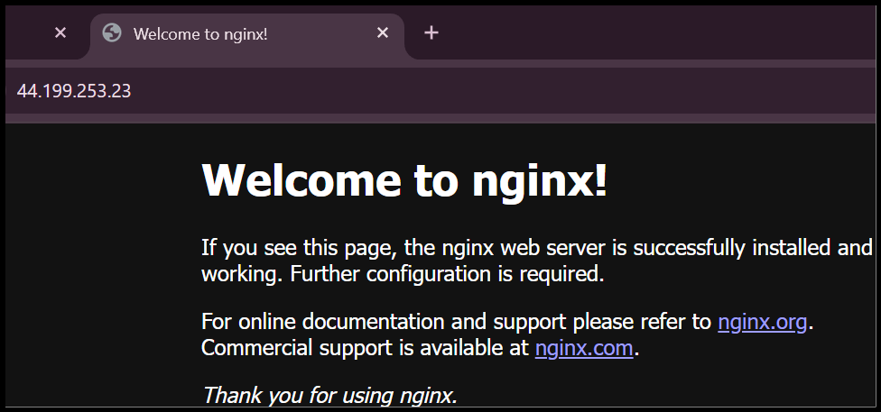
- Cleanup of Provisioned Resources
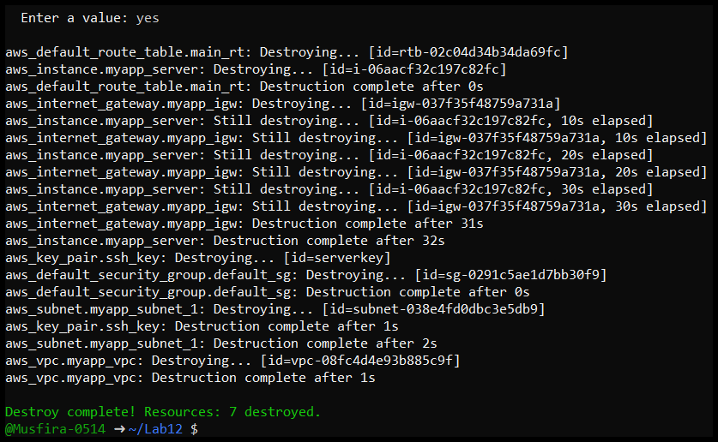
- Restoration of User Data Configuration
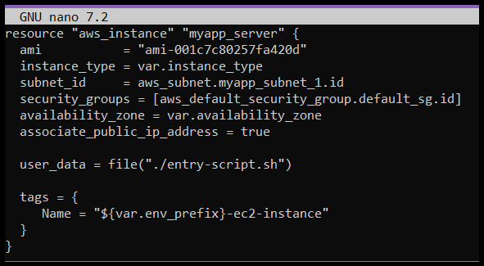
Task 4 – Subnet Module Creation
- Subnet Module Directory Structure
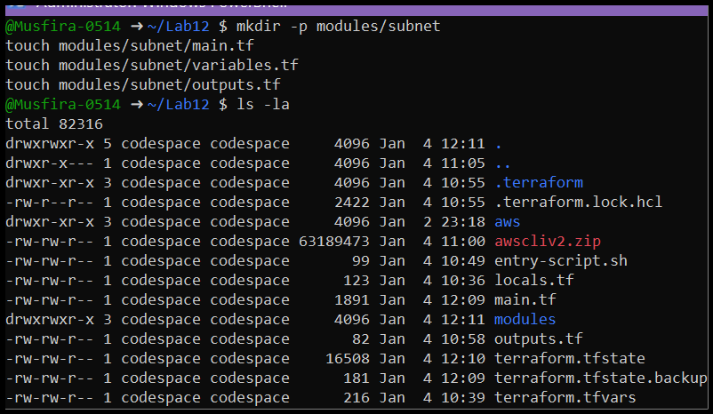
- Subnet Module Variables Definition
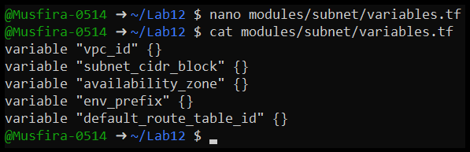
- Subnet Module Main Configuration
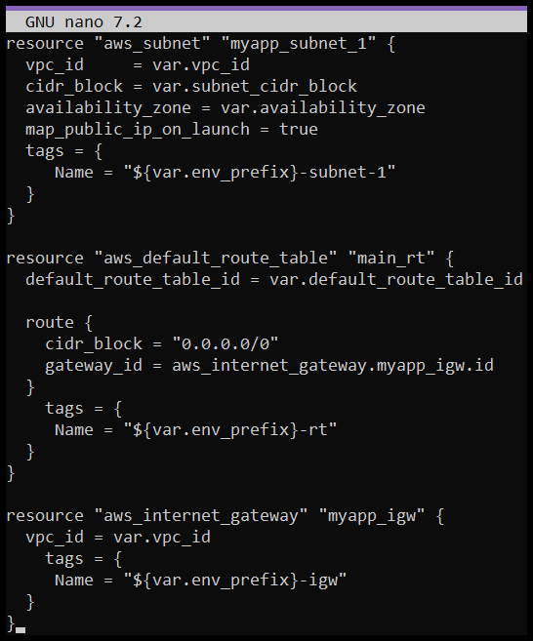
- Subnet Module Output Definition
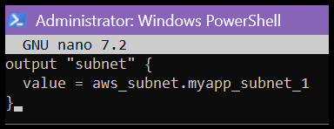
- Integration of Subnet Module in Root Configuration
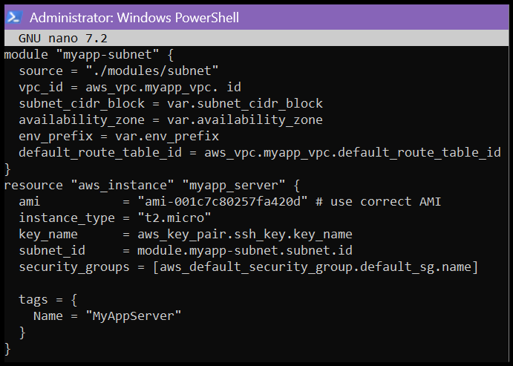
- Terraform Initialization with Module
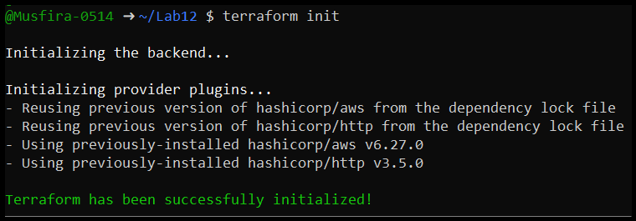
- Resource Creation Using Subnet Module
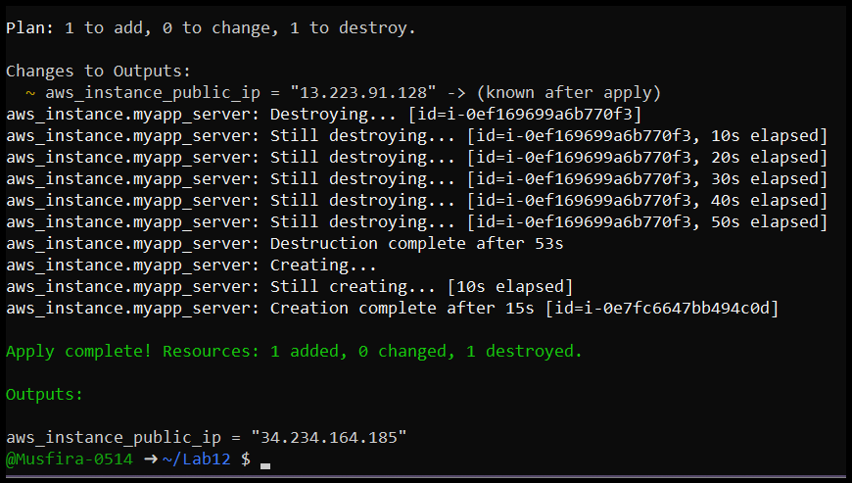
- Terraform Output After Module Deployment
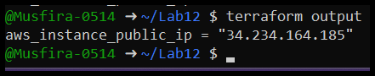
- Verification of Nginx Service
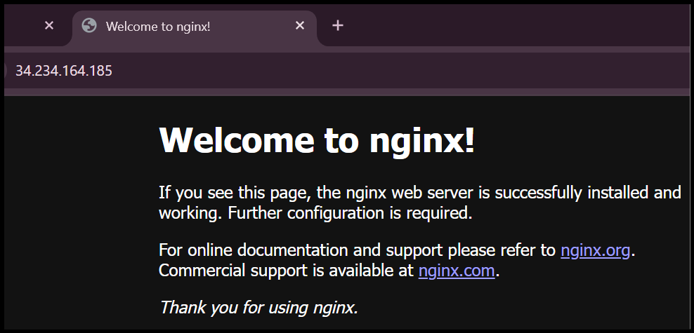
Task 5 – Webserver Module Creation
- Webserver Module Directory Structure
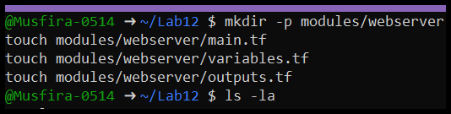
- Webserver Module Variable Definitions
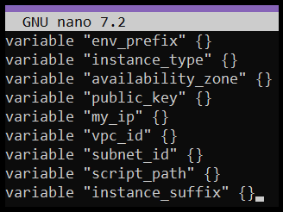
- Webserver Module Main Configuration
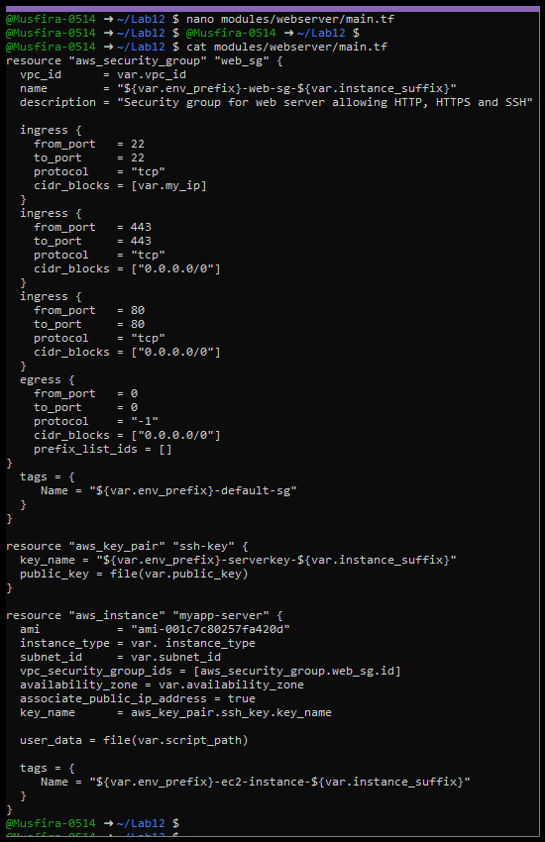
- Webserver Module Output Definition
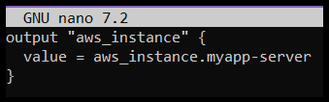
- Integration of Webserver Module in Root Configuration
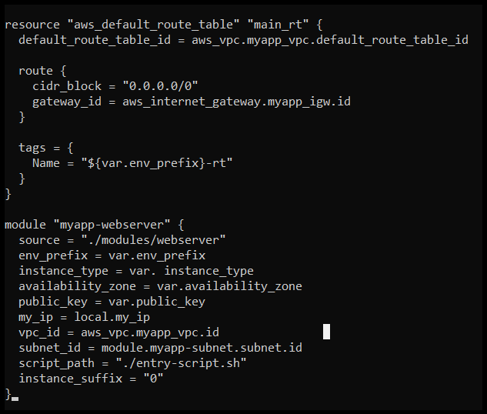
- Updated Terraform Outputs File
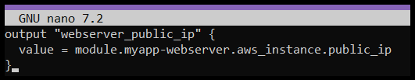
- Terraform Initialization
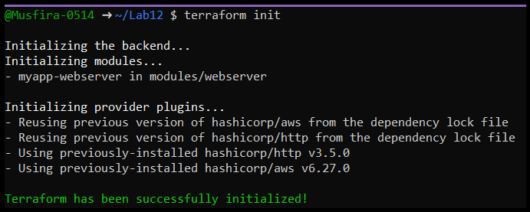
- Deployment of Webserver Module
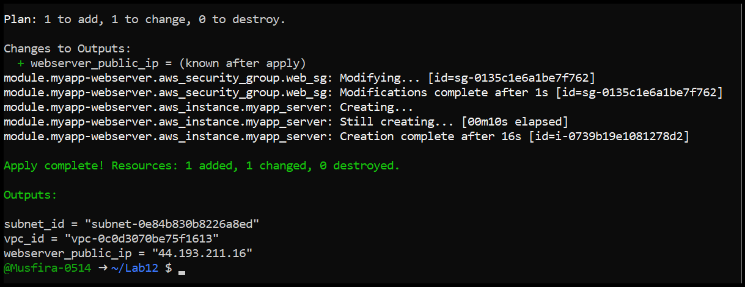
- Terraform Output Showing Webserver IP
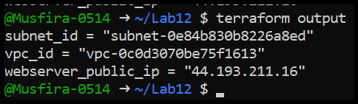
- Verification of Webserver in Browser
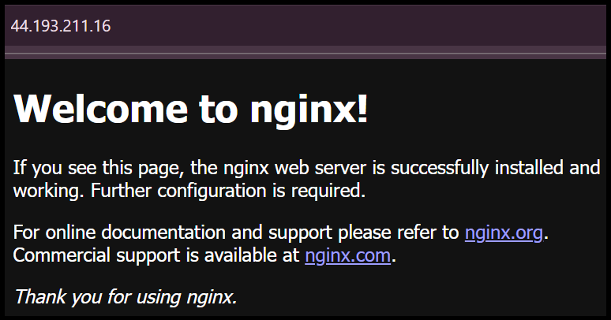
- Resource Cleanup
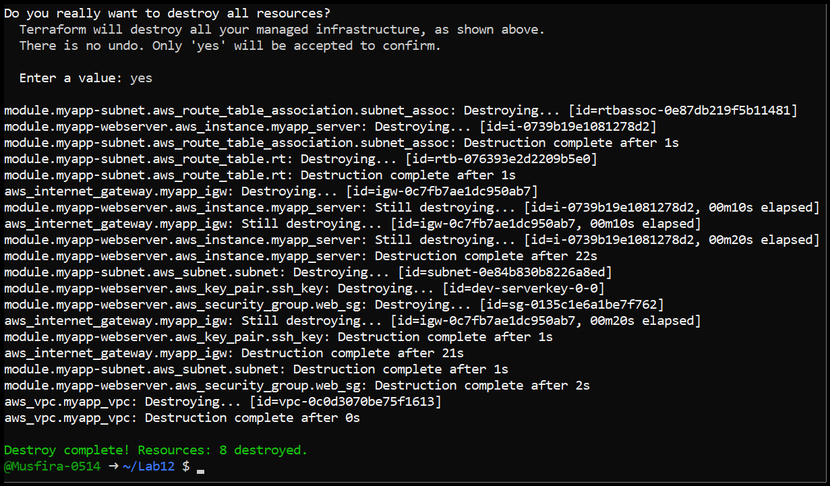
Task 6 – HTTPS with Self-Signed Certificates
- SSL-Enabled Nginx Configuration Script
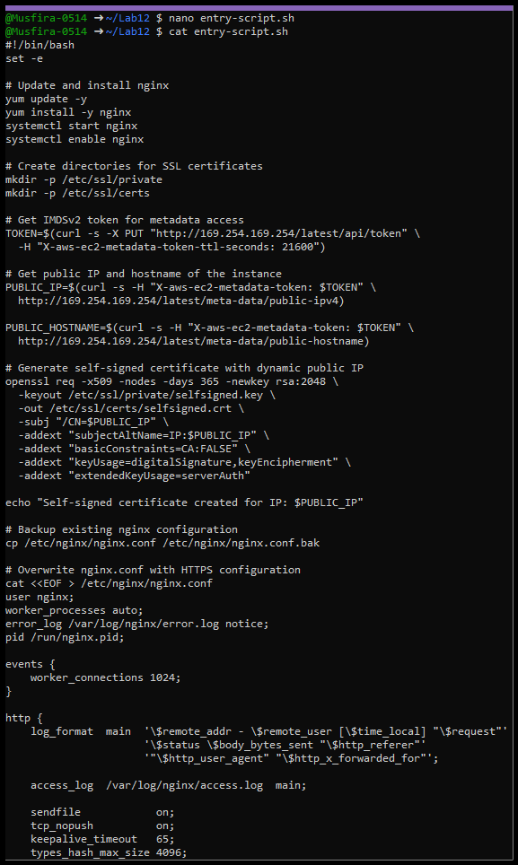

- Terraform Apply for HTTPS Setup
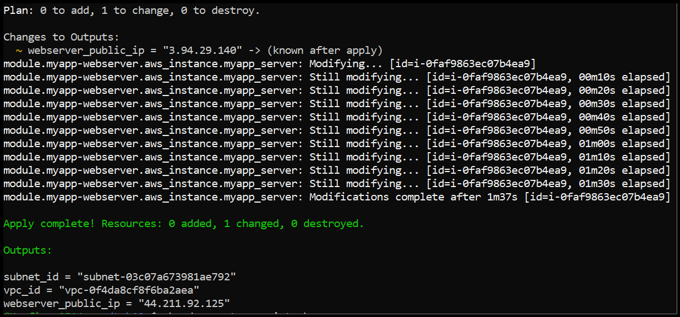
- Terraform Output After HTTPS Deployment
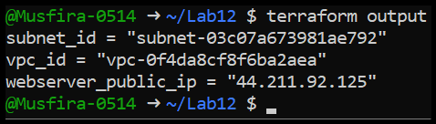
- Browser Security Warning for Self-Signed Certificate
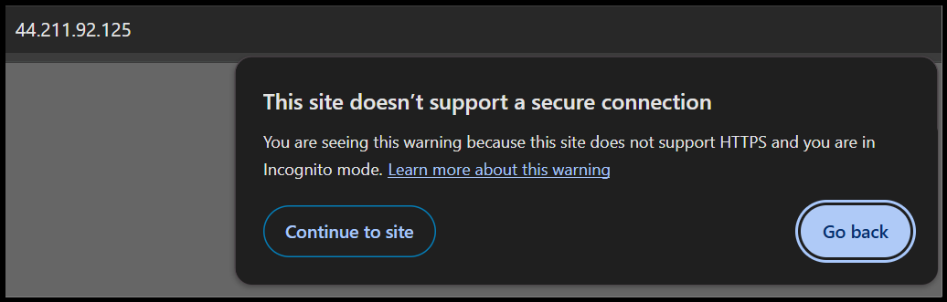
- Successful HTTPS Access to Nginx
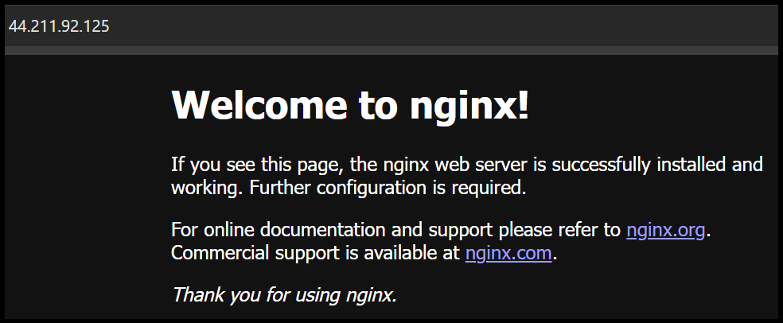
Task 7 — Configure Nginx as Reverse Proxy
- Apache Installation and Web Server Script
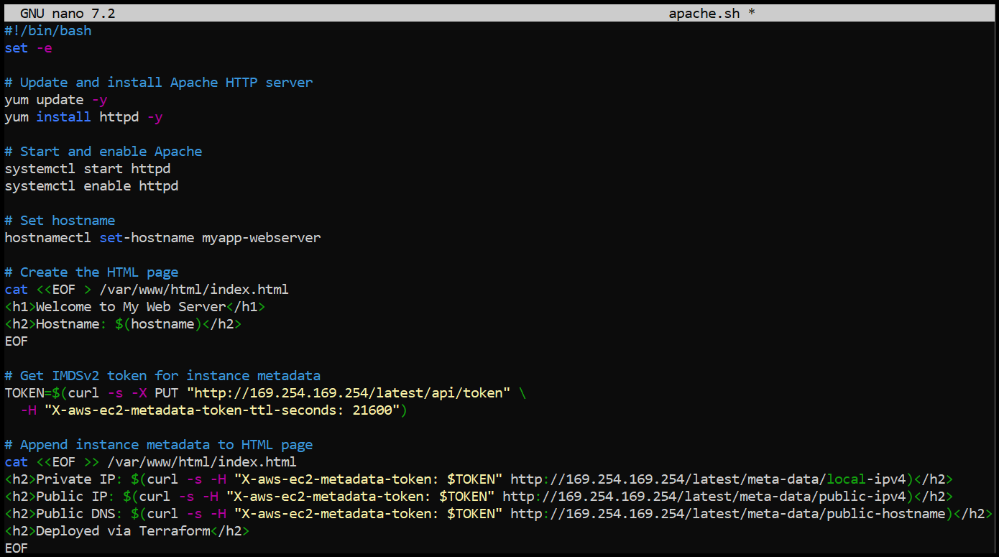
- Terraform Module for Backend Web Server (web-1) in main.tf
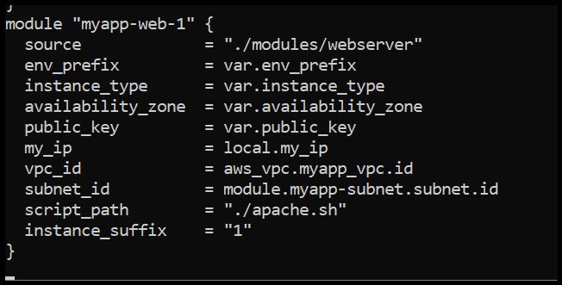
- Output Configuration for Web-1 Public IP
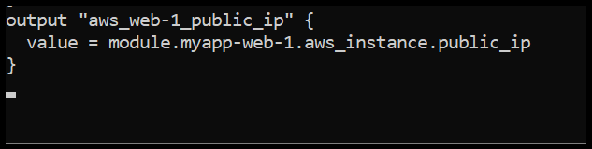
- Terraform Apply Output Showing Web-1 Creation
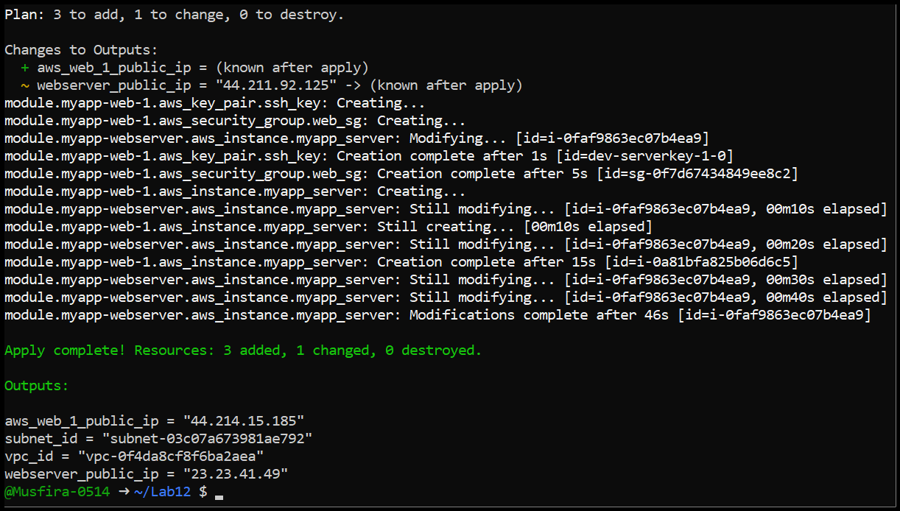
- Terraform Output Displaying Web-1 Public IP
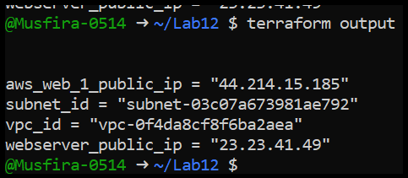
- SSH Session to Nginx Webserver
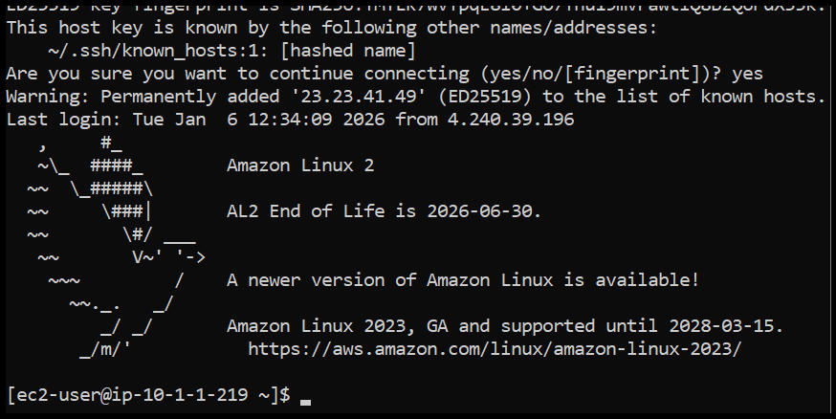
- Nginx Configuration with Reverse Proxy to Web-1
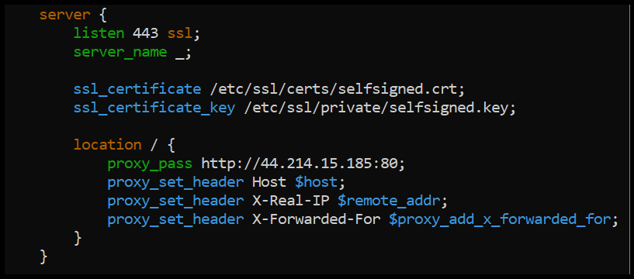
- Restarting Nginx Service
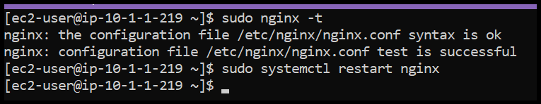
- Nginx Error Log Content
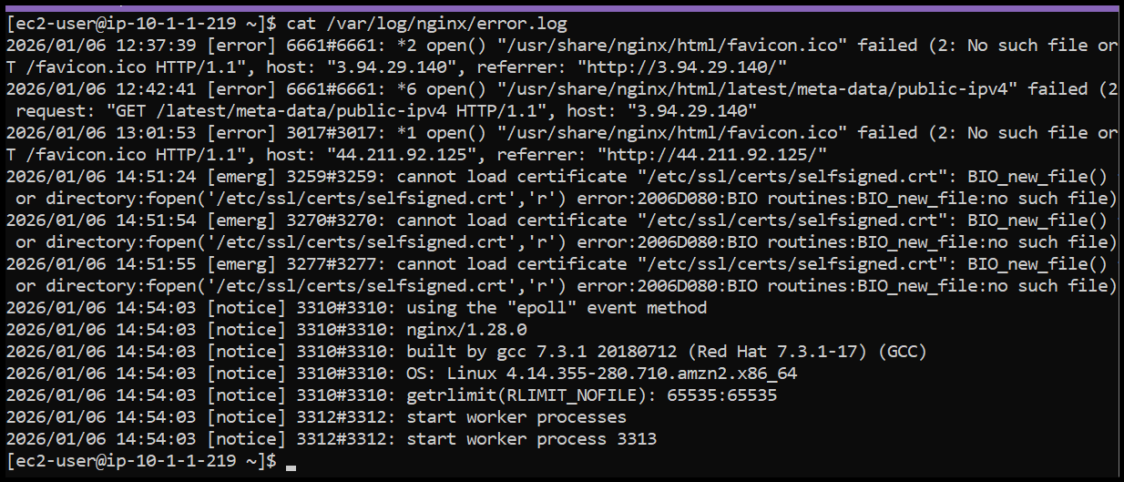
- Nginx Access Log Content
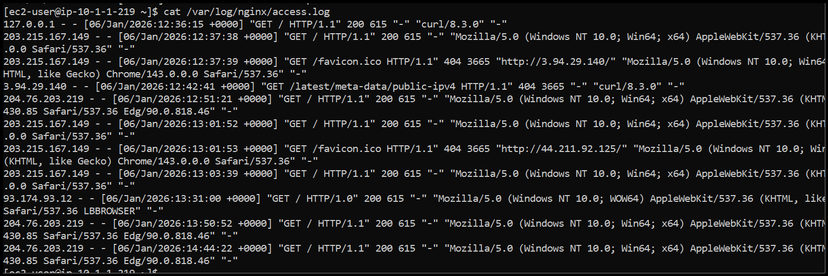
- Nginx MIME Types Configuration
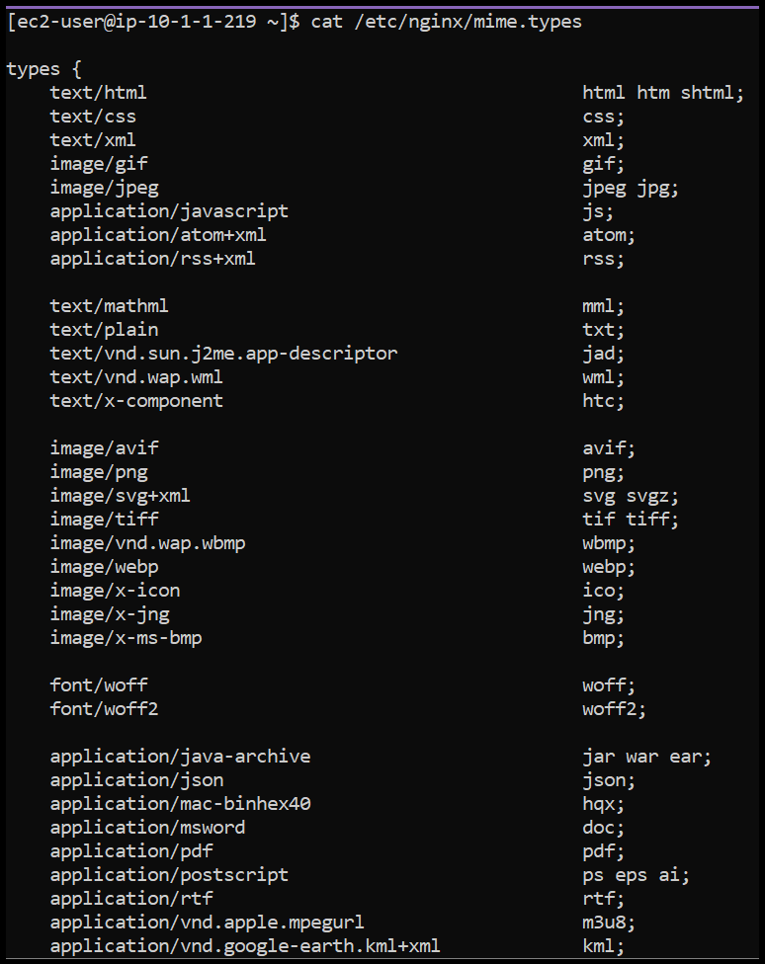
- Self-Signed SSL Certificate Content
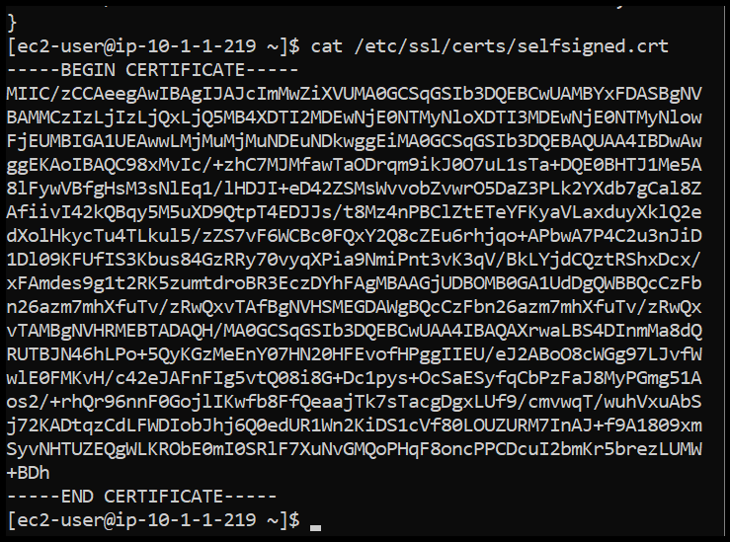
- SSL Private Key Content
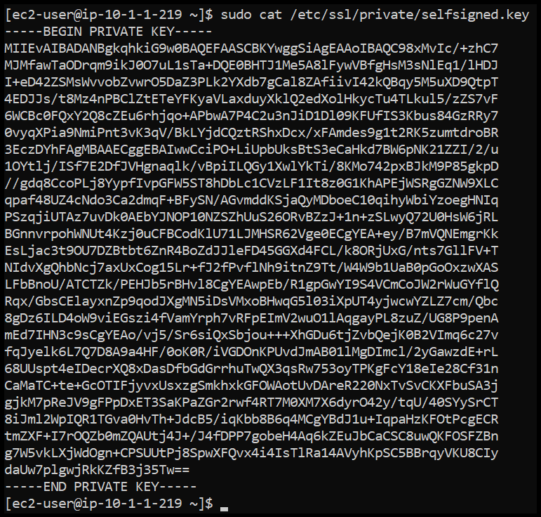
- Browser Showing Web-1 Content Through Nginx Proxy
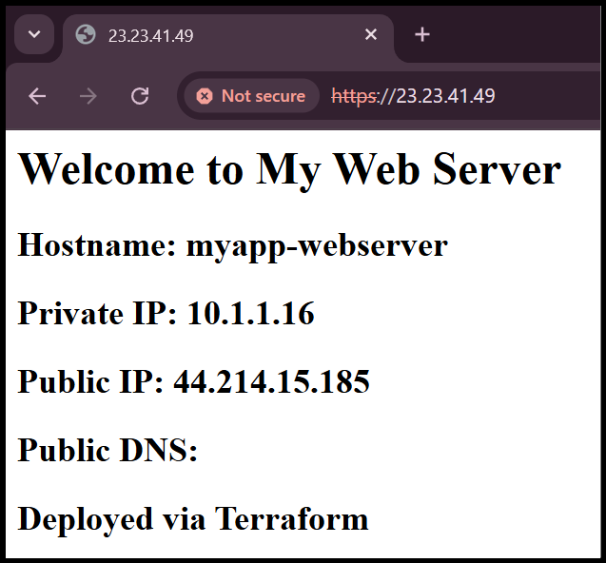
Task 8 — Configure Nginx as Load Balancer
- Terraform Module for Backend Web Server (web-2) in main.tf
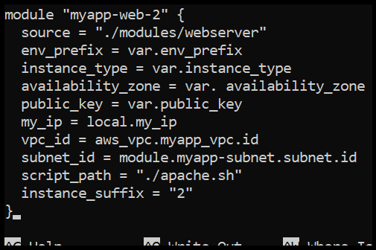
- Output Configuration for Web-2 Public IP
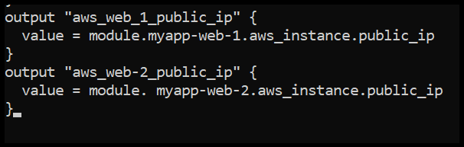
- Terraform Apply Output Showing Web-2 Creation
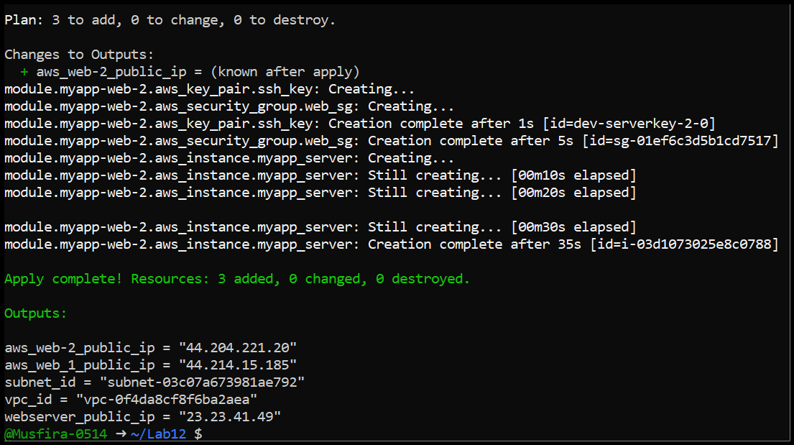
- Terraform Output Displaying All Public IPs
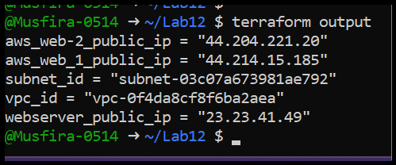
- Nginx Configuration for Load Balancing Between Web-1 and Web-2
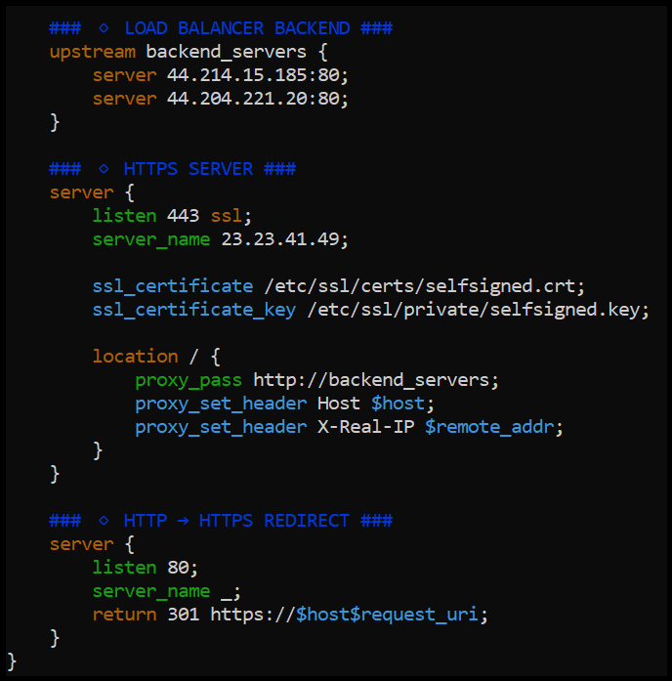
- Restarting Nginx Service After Load Balancer Configuration
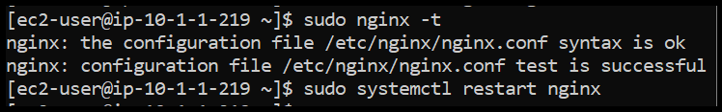
- Browser Showing Web-1 Content via Load Balancer
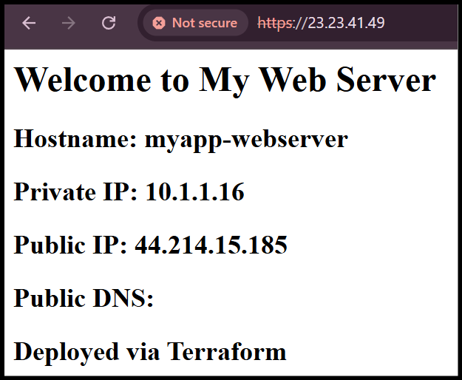
- Browser Showing Web-2 Content via Load Balancer
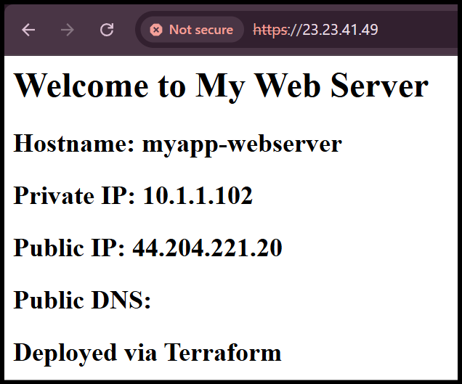
Task 9 — Configure High Availability with Backup Servers
- Nginx Configuration with Web-1 as Primary and Web-2 as Backup
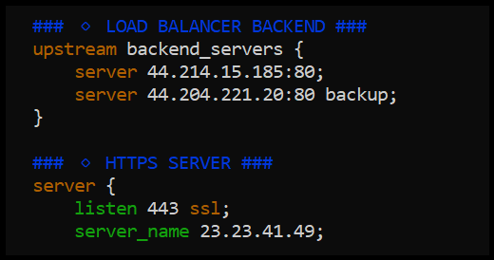
- Browser Showing Only Web-1 Content (Primary Server)
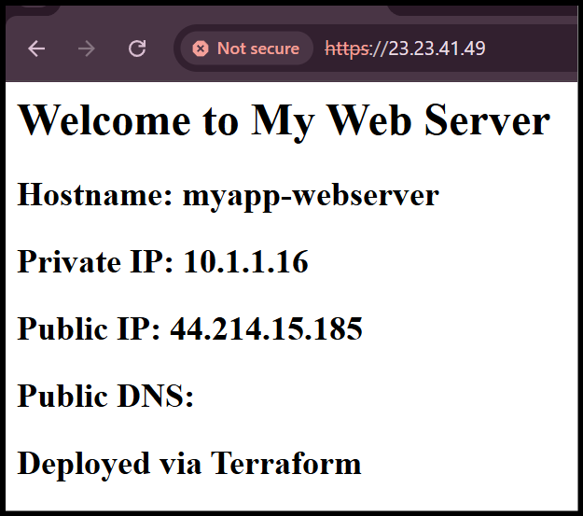
- Nginx Configuration with Web-2 as Primary and Web-1 as Backup
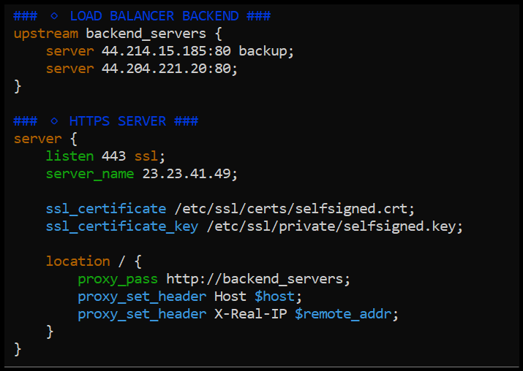
- Browser Showing Only Web-2 Content (Primary Server)
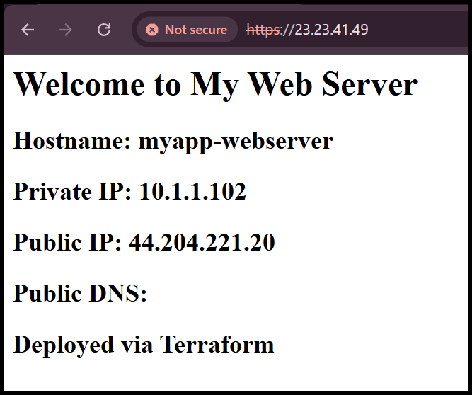
Task 10 — Enable Nginx Caching
- Nginx Configuration with Proxy Cache Enabled
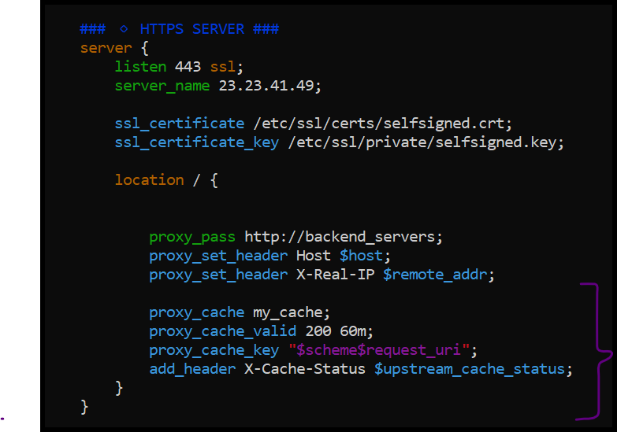
- Restarting Nginx Service After Cache Configuration
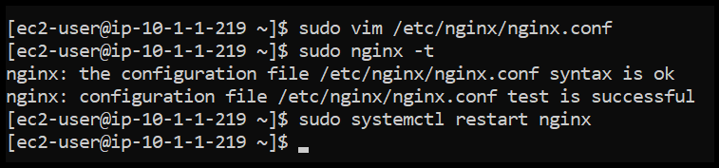
- Browser Developer Tools Showing Cache HIT on Subsequent Request
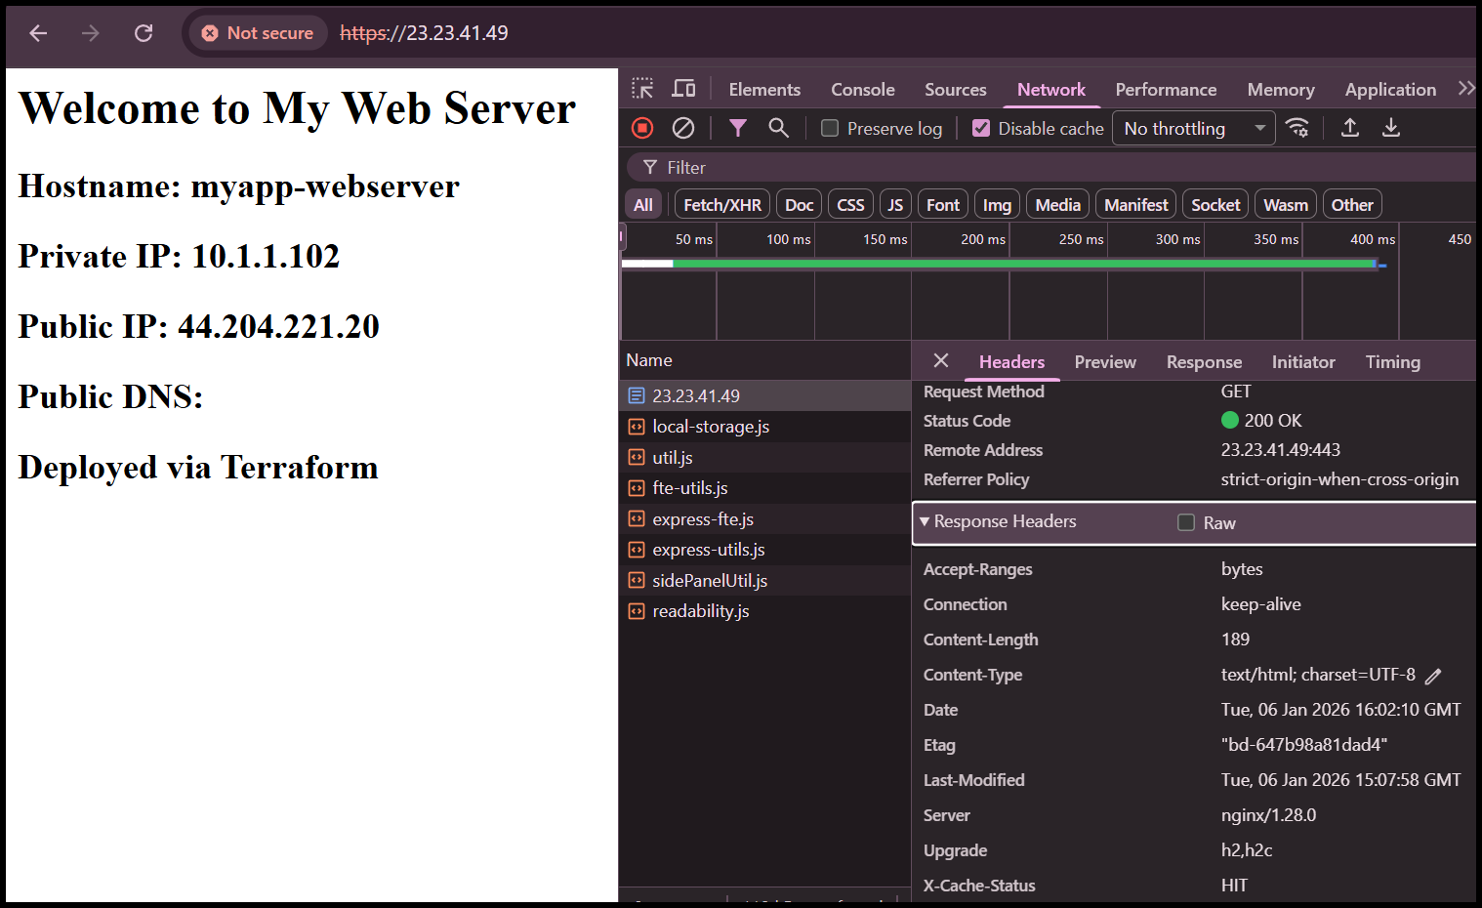
- Nginx Cache Directory Contents
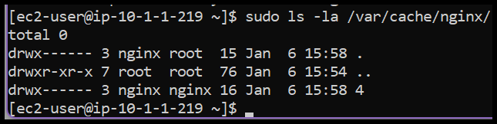
Cleanup
- Terraform Destroy Confirmation
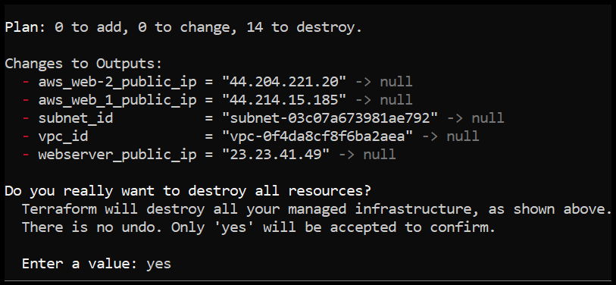
- Successful Resource Deletion
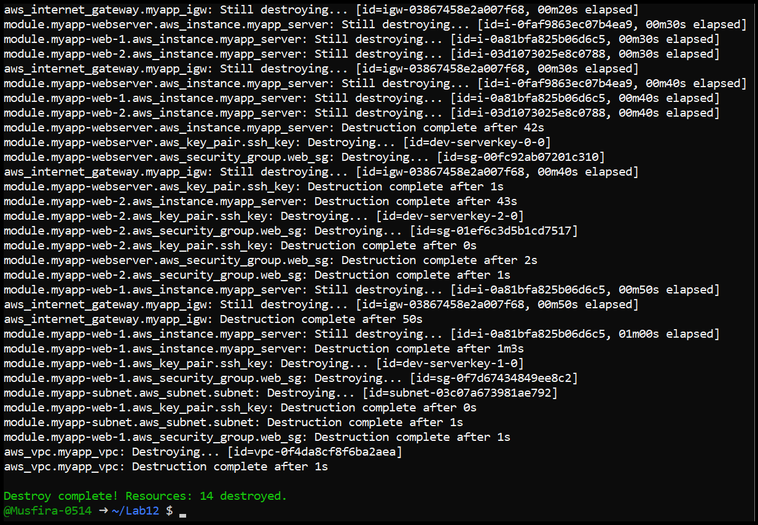
- Verification of Empty Terraform State
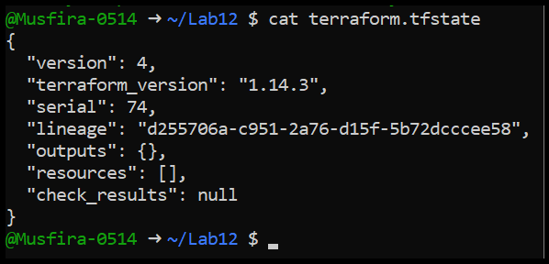
- Final Project File Structure
